SQL Sales Schema

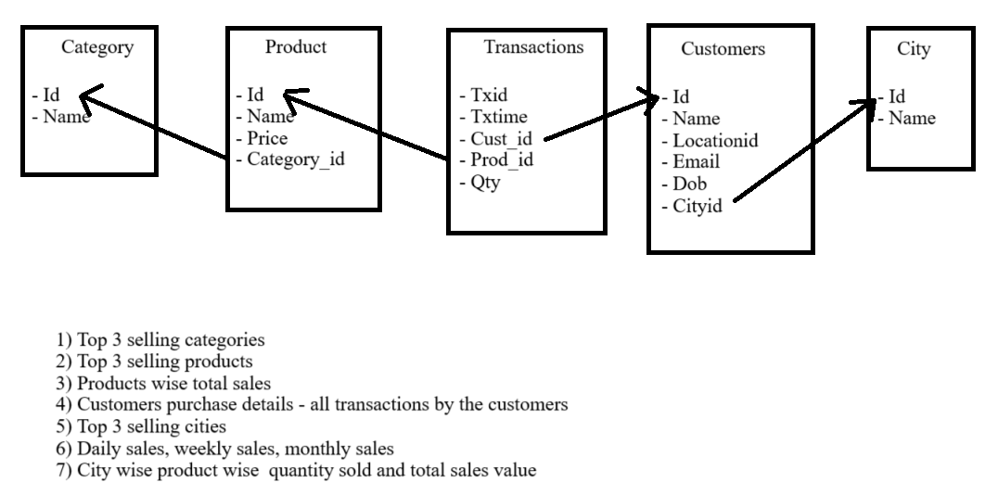

-------------------------------- Creating Tables ---------------------------------------

--1) Category

create table Category

(

id int primary key,

name varchar2(100)

);

insert into Category values(1, 'Kids');

insert into Category values(2, 'Men');

insert into Category values(3, 'Women');

insert into Category values(4, 'Sports');

insert into Category values(5, 'Electronics');

insert into Category values(6, 'Books');

insert into Category values(7, 'Laptop / Computers');

insert into Category values(8, 'Home');

insert into Category values(9, 'Cloths');

insert into Category values(10, 'Furniture');

insert into Category values(11, 'Grocery');

insert into Category values(12, 'Shoes');

select * from Category;

--2) Product

create table Product

(

id int primary key,

prodname varchar2(100),

price number(6,0),

category_id number(5,0)

);

insert into Product values (10, 'Toys', 1000, 1);

insert into Product values (20, 'Makeups', 1500, 2);

insert into Product values (30, 'Energy Drink', 2000, 3);

insert into Product values (40, 'Cricket', 2400, 4);

insert into Product values (50, 'Refrigerators', 77000, 5);

insert into Product values (60, 'Rhyms/Story', 100, 6);

insert into Product values (70, 'Acer', 40000, 7);

insert into Product values (80, 'Home lock', 500, 8);

insert into Product values (90, 'Shirts/T-shirt', 700, 9);

insert into Product values (100, 'Bed', 6000, 10);

insert into Product values (110, 'Oil', 200, 11);

insert into Product values (120, 'Adidaas', 3000, 12);

insert into Product values (130, '', 3000, 13);

insert into Product values (140, '', 1000, 14);

insert into Product values (150, '', 5000, 15);

select *

from Product;

-- 3) Transaction

create table Transactions

(

txid int primary key,

txtime timestamp not null,

cust_id number(6),

prod_id number(6),

qty number(7,0)

);

insert into transactions values(101,'10-aug-2024 01:20:09', 1101, 10, 207 );

insert into transactions values(102,'29-apr-2024 02:50:39', 1102, 20, 649 );

insert into transactions values(103,'15-jun-2024 10:20:10', 1103, 30, 1203 );

insert into transactions values(104,'01-sep-2024 05:30:12', 1104, 40, 1145 );

insert into transactions values(105,'17-feb-2024 01:20:09', 1105, 50, 232 );

insert into transactions values(106,'19-may-2024 03:50:39', 1106, 60, 63 );

insert into transactions values(107,'15-jul-2024 11:20:10', 1107, 70, 190 );

insert into transactions values(108,'18-may-2024 05:30:12', 1108, 80, 143 );

insert into transactions values(109,'10-aug-2024 01:20:09', 1109, 90, 832 );

insert into transactions values(110,'19-jun-2024 09:50:39', 1110, 100, 800 );

insert into transactions values(111,'03-apr-2024 12:20:10', 1111, 110, 1793 );

insert into transactions values(112,'21-jan-2024 07:30:12', 1112, 120, 2241 );

select *

from Transactions;

--4) Customers

create table Customers

(

id int primary key,

name varchar2(50),

locationid number(5),

email varchar2(60),

DOB varchar(60),

city_id number(5)

);

insert into Customers values(1101, 'Shani', 1501, 'ab@gmail.com', '10-03-2002', 1001 );

insert into Customers values(1102, 'Nikita', 1502, 'nikita@gmail.com', '20-06-2005', 1002 );

insert into Customers values(1103, 'Amit', 1503, 'amit@gmail.com', '30-04-2004', 1003 );

insert into Customers values(1104, 'Ratan', 1504, 'ratan@gmail.com', '13-03-2001', 1004 );

insert into Customers values(1105, 'Ritu', 1505, 'ritu@gmail.com', '10-07-2003', 1005 );

insert into Customers values(1106, 'Pravin', 1506, 'pravin@gmail.com', '15-07-2000', 1006 );

insert into Customers values(1107, 'Piyush', 1507, 'piyush@gmail.com', '30-07-2003', 1007 );

insert into Customers values(1109, 'Gaurav', 1509, 'Gaurav@gmail.com', '10-07-1999', 1009 );

insert into Customers values(1111, 'Sachin', 1511, 'sachin@gmail.com', '18-12-2003', 1011 );

insert into Customers values(1112, 'Rina', 1512, 'rina@gmail.com', '10-07-2003', 1012 );

insert into Customers values(1113, 'Rekha', 1513, 'Rekha@gmail.com', '10-07-2003', 1013 );

insert into Customers values(1114, 'David', 1514, 'david@gmail.com', '10-02-2001', 1014 );

insert into Customers values(1115, 'Nancy', 1515, 'nancy@gmail.com', '12-07-2005', 1015 );

insert into Customers values(1117, 'Rakesh', 1517, 'rakesh@gmail.com', '10-07-1998', 1017 );

insert into Customers values(1118, 'Ishan', 1518, 'ishan@gmail.com', '15-08-1994', 1018 );

insert into Customers values(1119, 'Trisha', 1519, 'trisha@gmail.com', '23-07-1997', 1019 );

insert into Customers values(1120, 'Piya', 1520, 'piya@gmail.com', '10-03-2005', 1020 );

insert into Customers values(1121, 'Shelli', 1521, 'shelli@gmail.com', '17-12-1970', 1021 );

insert into Customers values(1122, 'Kevin', 1522, 'kevin@gmail.com', '10-07-1990', 1022 );

insert into Customers values(1123, 'Riya', 1523, 'riya@gmail.com', '10-01-2003', 1023 );

insert into Customers values(1125, 'James', 1525, 'james@gmail.com', '10-11-2004', 1025 );

insert into Customers values(1126, 'Jay', 1526, 'jay@gmail.com', '20-09-2003', 1026 );

insert into Customers values(1127, 'Prakash', 1527, 'prakash@gmail.com', '10-12-1992', 1027 );

insert into Customers values(1128, 'Ki', 1528, 'ki@gmail.com', '19-07-2000', 1028 );

insert into Customers values(1130, 'DJ', 1530, 'dj@gmail.com', '15-10-1989', 1030 );

insert into Customers values(1131, 'PK', 1531, 'pk@gmail.com', '05-12-1989', 1031 );

insert into Customers values(1132, 'Munna', 1532, 'mn@gmail.com', '13-11-1999', 1032 );

insert into Customers values(1133, 'PSS', 1533, 'ps@gmail.com', '02-01-1979', 1033 );

insert into Customers values(1134, 'Kie', 1534, 'kie@gmail.com', '12-03-2000', 1034 );

insert into Customers values(1135, 'Li', 1535, 'li@gmail.com', '09-07-2002', 1035 );

insert into Customers values(1136, 'Prince', 1536, 'pr@gmail.com', '18-03-2000', 1036 );

insert into Customers values(1137, 'Lee', 1537, 'lee@gmail.com', '19-02-2000', 1037 );

insert into Customers values(1138, 'Sling', 1538, 'sgi@gmail.com', '16-08-2000', 1038 );

insert into Customers values(1139, 'King', 1539, 'kn@gmail.com', '12-07-2002', 1039 );

insert into Customers values(1140, 'tat', 1540, 'ta@gmail.com', '17-09-2001', 1040 );

select *

from Customers;

--5) City

create table City

(

id int primary key,

name varchar2(70)

);

insert into City values(1001, 'Mumbai');

insert into City values(1002, 'Thane');

insert into City values(1003, 'Nashik');

insert into City values(1004, 'Pune');

insert into City values(1005, 'Delhi');

insert into City values(1006, 'Patna');

insert into City values(1007, 'Bangalore');

insert into City values(1008, 'Gandhinagar');

insert into City values(1009, 'kolkata');

insert into City values(1010, 'London');

insert into City values(1011, 'Lonavala');

insert into City values(1012, 'New York');

insert into City values(1013, 'New Delhi');

insert into City values(1014, 'Navi Mumbai');

insert into City values(1015, 'Dahanu');

insert into City values(1016, 'Panji');

insert into City values(1017, 'Varanasi');

insert into City values(1018, 'Lucknow');

insert into City values(1019, 'Ratnagiri');

insert into City values(1020, 'Dhule');

select *

from City;

--------------------------- Joining The Tables -------------------------------

select *

from (Category) c, (Product) p, (Transactions) t, (Customers) cu, (City) ct

where c.id = p.category_id and p.id = t.prod_id and t.cust_id = cu.id and cu.city_id = ct.id;

------------------------------------ Questions ------------------------------------

--1) Find a top 3 selling products.

-- Method A) In method A dense_rank is used for indexing

select *

from (select catename, total_sales, (dense_rank() over (order by total_sales desc)) Top_3

from (select c.name catename, sum(p.price*t.qty) total_sales

from Category c, Product p, Transactions t

where c.id = p.category_id and p.id = t.prod_id

group by c.name

order by 2))

where Top_3 <= 3;

-- Method B) In method B rownum is used for indexing.

select *

from( select c.name, sum(p.price*t.qty) total_sales

from (Category) c, (Product) p, (Transactions) t

where c.id = p.category_id and p.id = t.prod_id

group by c.name

order by 2 desc)

where rownum <=3;

--2) Find a top 3 selling Products.

--Ans. It is sales wise top 3 selling products.

select *

from ( select pname, total_sales2, (dense_rank() over (order by total_sales2 desc)) top_3

from ( select p.prodname pname, sum(t.qty*p.price) total_sales2

from (Product) p, (Transactions) t

where p.id = t.prod_id

group by p.prodname

order by 2))

where top_3 <=3;

--3) Find a Product wise total sales.

--Ans. This is a product wise total sales of all products.

select *

from ( select rownum , product_name, total_sales

from(select p.prodname product_name, (t.qty*p.price) total_sales

from (Product) p, (Transactions) t

where p.id = t.prod_id

order by 2));

--4) Customers purchase details - all transaction by the customers.

--Ans. Below query shows the customers purchasing details and all transactions of customers and also shows the customers details.

select p.prodname products, t.txid, t.txtime trans_time, cu.name customers, cu.email emails, (t.qty*p.price) transactions

from (Product) p, (Transactions) t, (Customers) cu

where p.id = t.prod_id and t.cust_id = cu.id

order by customers;

--5) Find a top 3 selling cities.

select *

from (select city_name, total_sale, (dense_rank() over (order by total_sale desc)) top3_cities

from (select ct.name city_name, (t.qty*p.price) total_sale

from (Product) p, (Transactions) t, (Customers) cu, (City) ct

where p.id = t.prod_id and t.cust_id = cu.id and cu.city_id = ct.id))

where top3_cities <=3;

--6) Find the Daily sales, weekly sales and monthly sales.

--A) Daily sales

select to_char(t.txtime, 'DD-MM-YYYY') sales_date, p.prodname product, p.price, (t.qty*p.price) Total_sales

from (Product) p, (Transactions) t

where p.id = t.prod_id

--B) Weekly sales

select to_char(t.txtime, 'IW') weekly_sales, p.prodname products, p.price, (t.qty*p.price) Total_sales

from (Product) p, (Transactions) t

where p.id = t.prod_id

order by 1;

--C) Monthly sales

select to_char(t.txtime, 'MM') monthly_sales, p.prodname products, p.price, (t.qty*p.price) Total_sales

from (Product) p, (Transactions) t

where p.id = t.prod_id

order by 1;

--7) Find city wise product wise quantity sold and total sales value.

select ct.name city_name, p.prodname product, t.qty quantity, sum(t.qty*p.price) total_sale

from (Product) p, (Transactions) t, (Customers) cu, (City) ct

where p.id = t.prod_id and t.cust_id = cu.id and cu.city_id = ct.id

group by ct.name , p.prodname , t.qty

order by 1,2;